Manual Test Plan

**Test 1: Opening the Game**

Steps:

1. No steps to take (besides running the program)

Observe:

* The board is created with alternating light and dark squares
* Option panel at the bottom includes New Game, Rest, Forfeit, Undo and Redo
* Dialog prompts the user to enter their names
* Cancelling or exiting the dialog will return to the same screen

Screenshot:

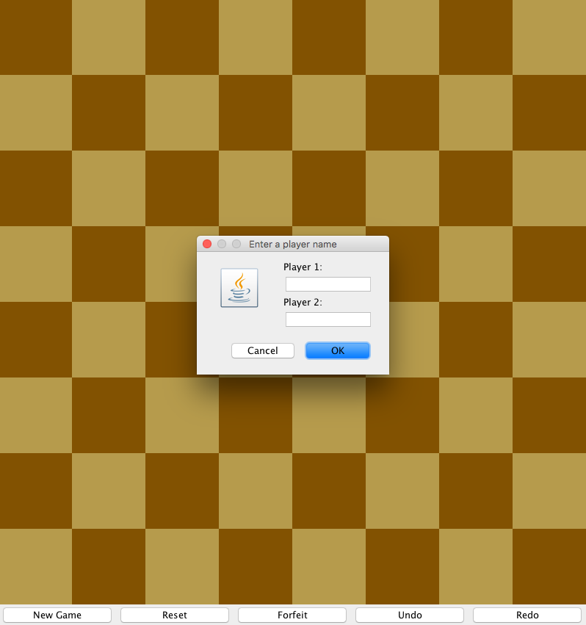

**Test 2: Initializing the Game**

Steps:

1. Enter “Hello” into Player 1 and “World” into Player 2
2. Click “OK”

Observe:

* The black pieces are laid out on the top and white pieces are laid on on the bottom
* The pieces are all laid out following the rules of a traditional chess game
* Score panel is added to the top of the screen with the player’s names and scores
* Score panel includes which player’s turn it is

Screenshot:

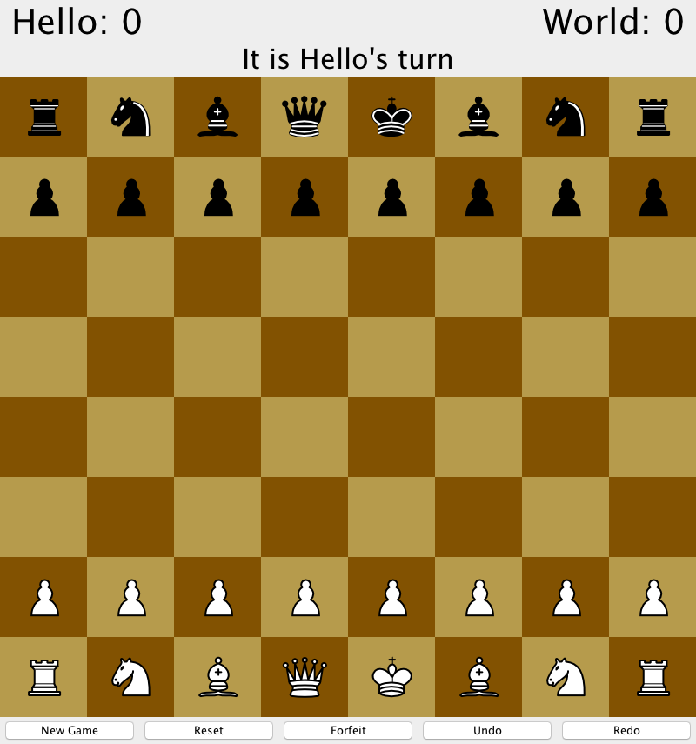

**Test 3: Invalid Selection**

Steps:

1. After initialization, click on an invalid square
   1. Option 1: Click on the empty square at (4,4)
   2. Option 2: Click on an enemy piece’s square at (0,0)

Observe:

* There are no changes to the placement of the pieces on the board
* There is a pop-up dialog that warns the user to select a valid square

Screenshot:

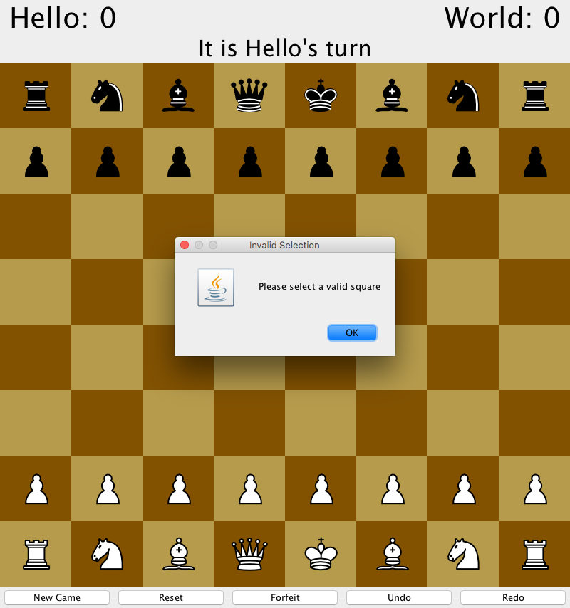

**Test 4: Invalid Undo**

Steps:

1. After initialization, click “Undo”

Observe:

* There are no changes to the placement of the pieces on the board
* There is a pop-up dialog that warns there are no moves to undo

Screenshot:

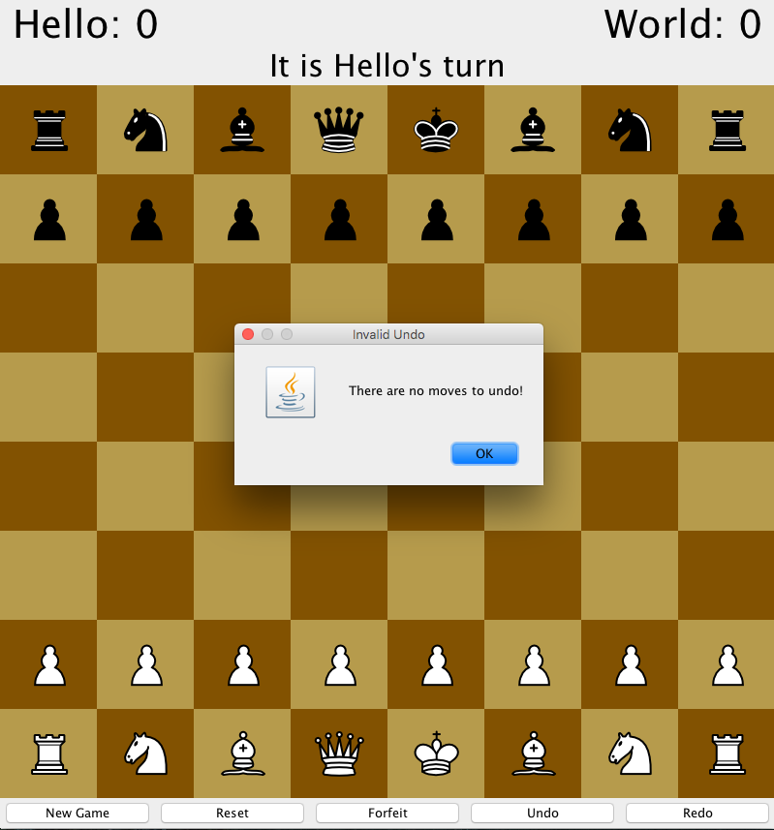**Test 5: Invalid Redo**

Steps:

1. After initialization, click “Undo”

Observe:

* There are no changes to the placement of the pieces on the board
* There is a pop-up dialog that warns there are no moves to redo

Screenshot:

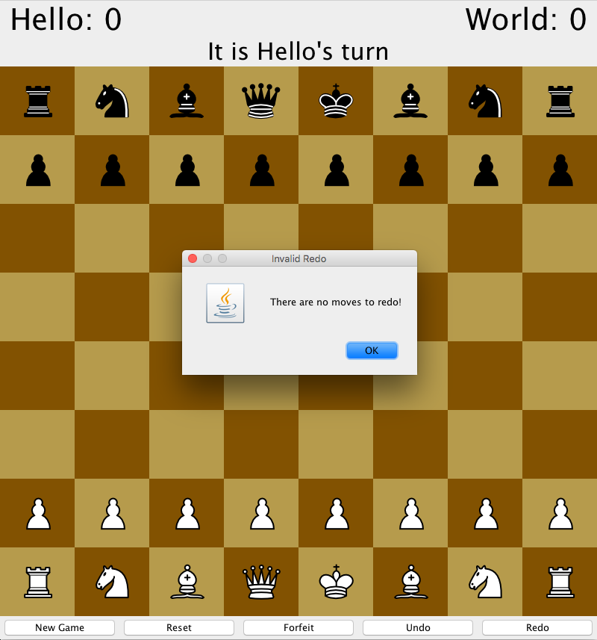**Test 6: Select Piece**

Steps:

1. Click on the White Pawn on (3,6)

Observe:

* The White Pawn icon is highlighted in red
* The possible moves for the White Pawn are highlighted in green

Screenshot:

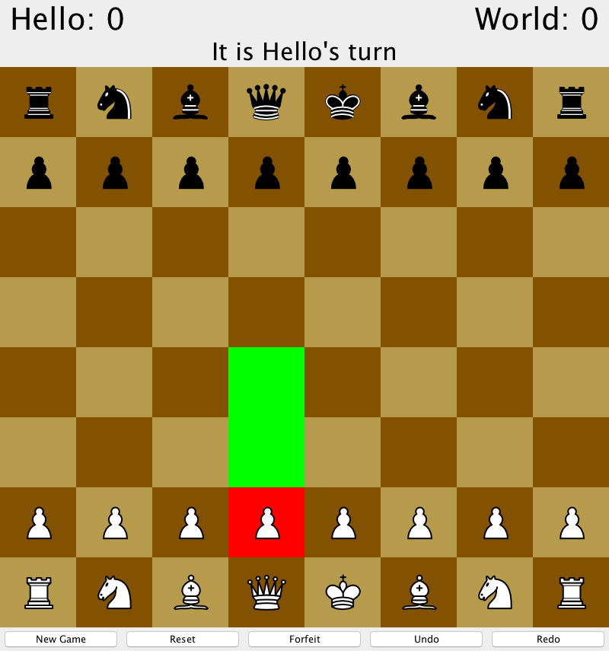

**Test 7: Invalid Move**

Steps:

1. Select the White Pawn at (3,6)
2. Select a non-green square (eg. 3,3)

Observe:

* There are no changes to the placement of the pieces on the board
* There is a pop-up dialog that warns the move is invalid

Screenshot:

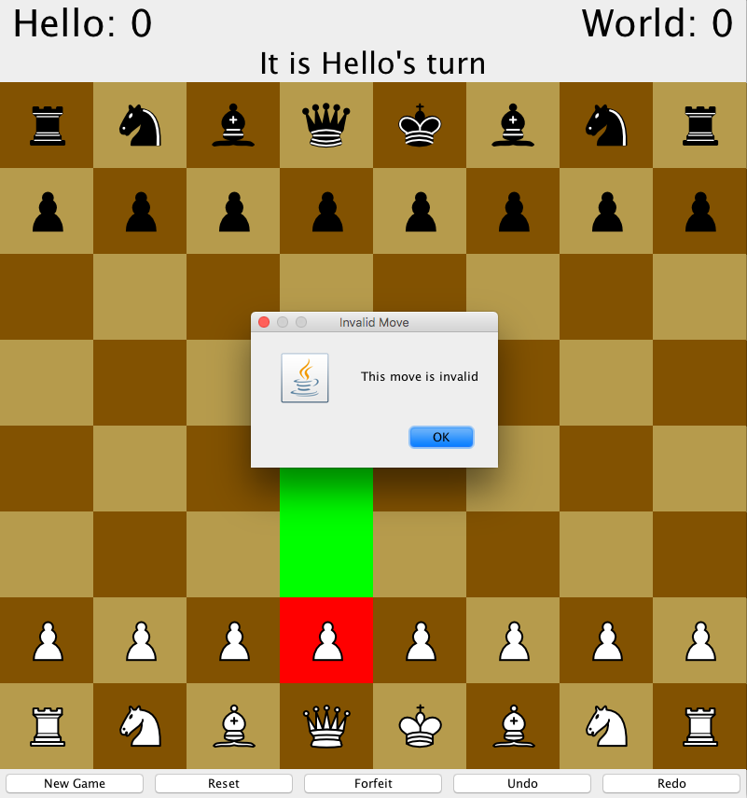

**Test 8: Valid Move**

Steps:

1. Select the White Pawn at (3,6)
2. Select the green square (3,4)

Observe:

* The White Pawn is moved to (3,4)
* The square at (3,6) has no piece on it
* The turn label is changed to World

Screenshot:

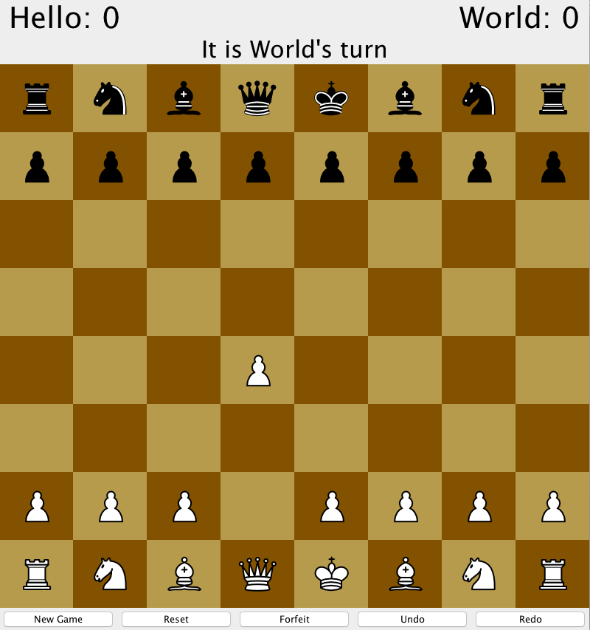

**Test 9: Eating an Enemy Piece**

Steps:

1. Move White Pawn from (3,6) to (3,4)
2. Move Black Pawn from (4,1) to (4,3) : Fig 1
3. Move White Pawn from (3,4) to (4,3) : Fig 2

Observe:

* The White Pawn is on (4,3)
* The Black Pawn is removed from the board
* The turn label is changed from Hello to World

Screenshot:

1: 2:

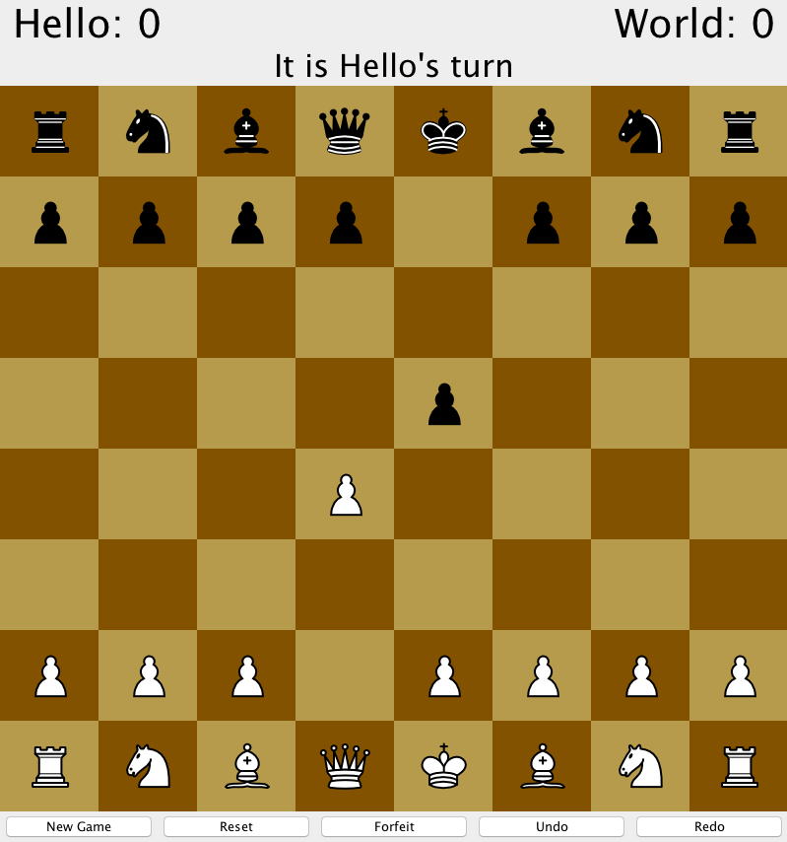 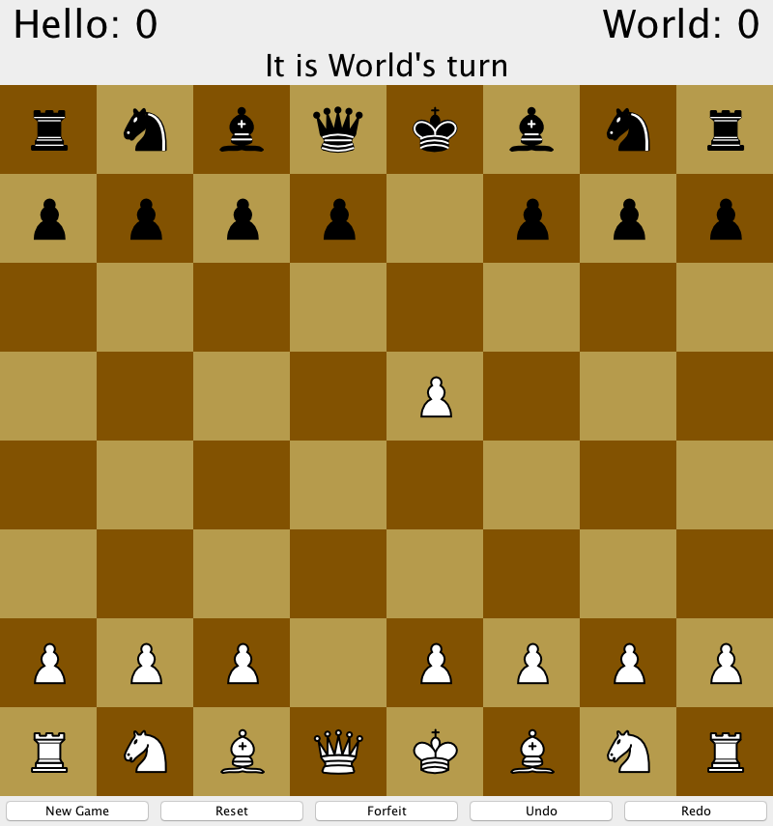

**Test 10: Undo a Move**

Steps:

1. Repeat steps from Test 9
2. Press “Undo”

Observe:

* The White Pawn is moved back to (3,4)
* The eaten Black Pawn is set on (4,3)
* The turn label is changed back to Hello

Screenshot:

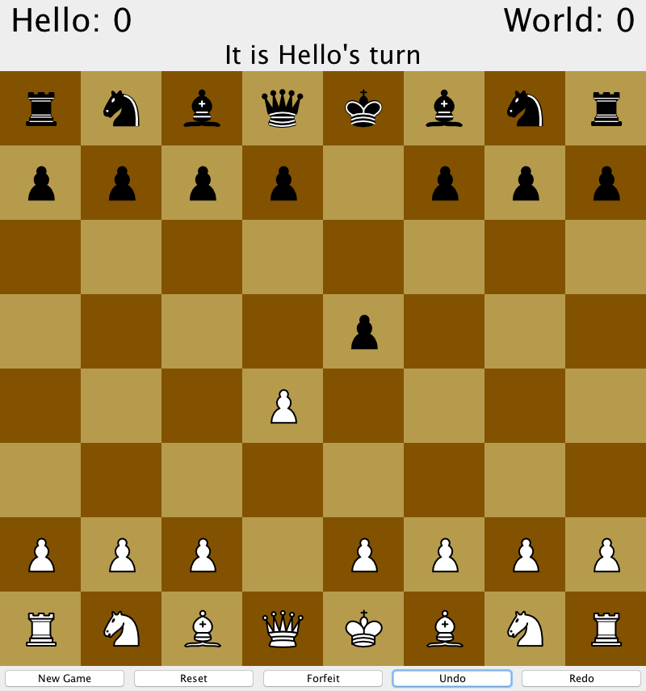

**Test 11: Undo Multiple Moves**

Steps:

1. Repeat steps from Test 10
2. Press “Undo”

Observe:

* The White Pawn is moved back to (3,4)
* The eaten Black Pawn is set on (4,1)
* The turn label is changed back to Word

Screenshot:

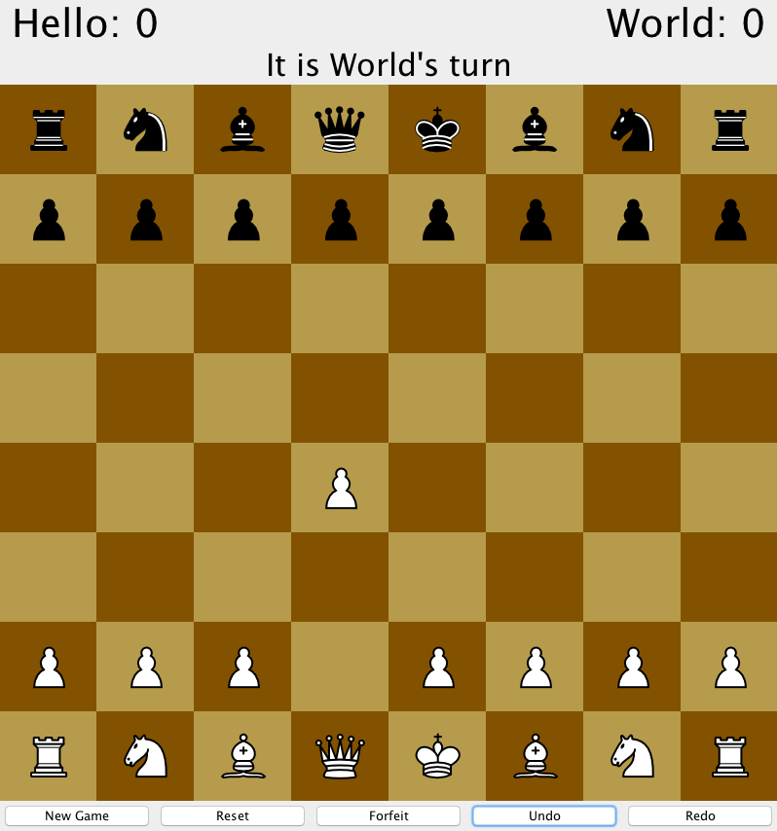

**Test 12: Redo a Move**

Steps:

1. Repeat steps from Test 11
2. Press “Redo”

Observe:

* The White Pawn stays on (3,4)
* The Black Pawn is moved to (4,3)
* The turn label is changed back to Hello

Screenshot:



**Test 13: Redo Multiple Moves**

Steps:

1. Repeat steps from Test 12
2. Press “Redo”

Observe:

* The White Pawn is moved back to (4,3)
* The eaten Black Pawn is removed from the board
* The turn label is changed back to Word

Screenshot:

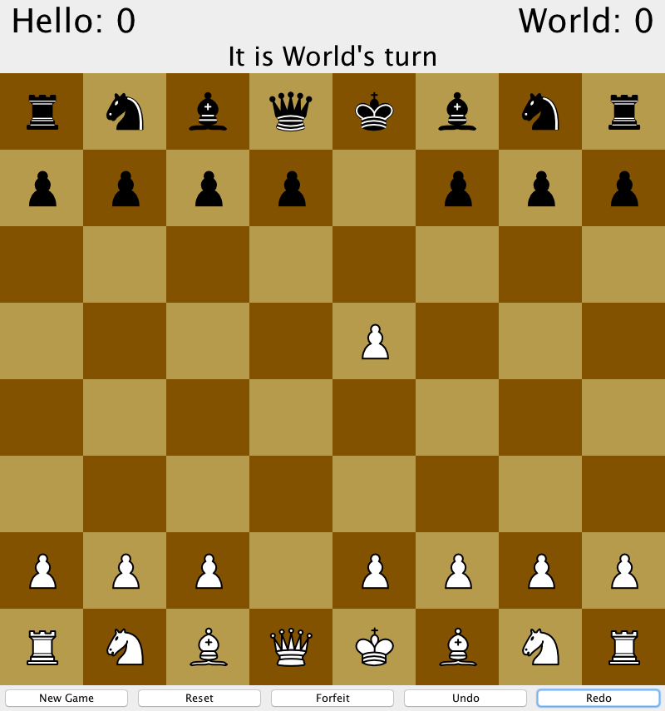

**Test 14: Forfeit Game**

Steps:

1. Continuing from Test 13
2. Press “Forfeit”[Fig. 1]
3. Press “OK” [Fig. 2]

Observe:

* Fig 1
  + There is a pop-up dialog that confirms if the user wants to forfeit
* Fig 2
  + The play again dialog appears
  + The score for Hello is increased to 1

Screenshot:

1: 2:

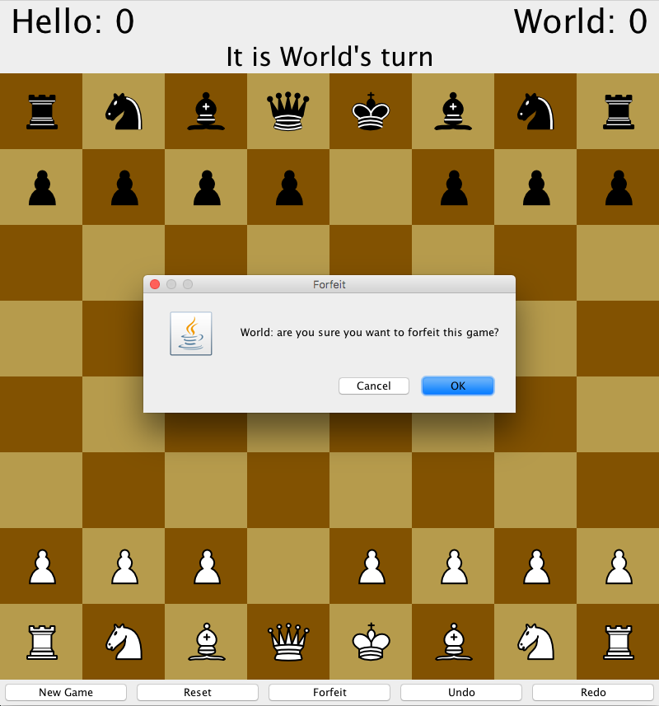 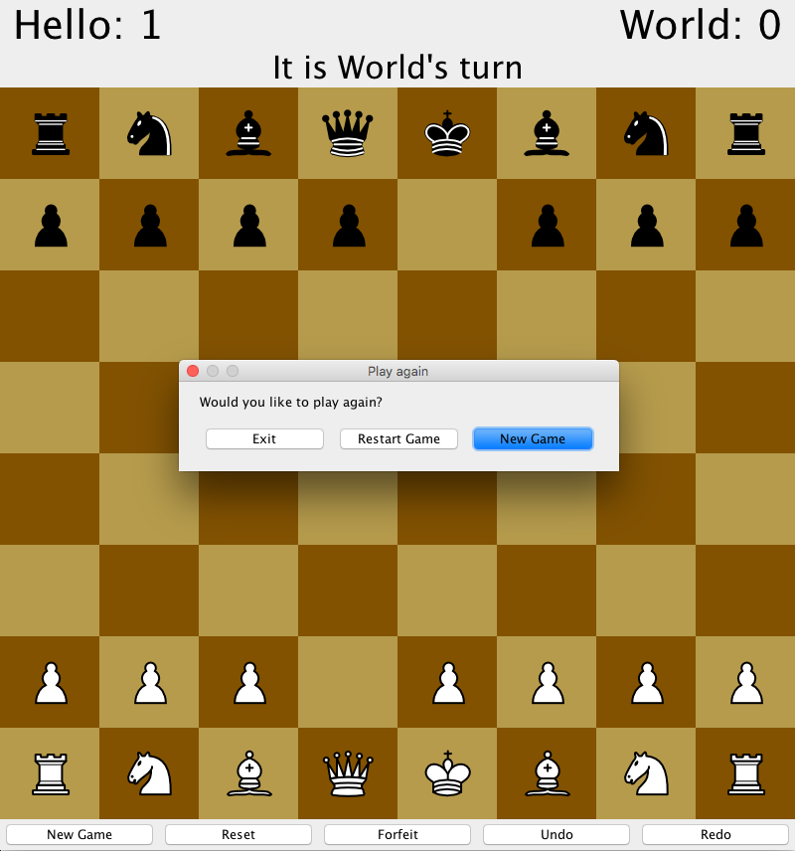

**Test 15: Reset Game from Play Again**

Steps:

1. Repeat steps from Test 14
2. Press “Restart Game”

Observe:

* The black pieces are laid out on the top and white pieces are laid on on the bottom
* The pieces are all laid out following the rules of a traditional chess game
* Player names are kept the same as before
* Hello’s score is kept the same as before
* Turn is changed to Hello

Screenshot:

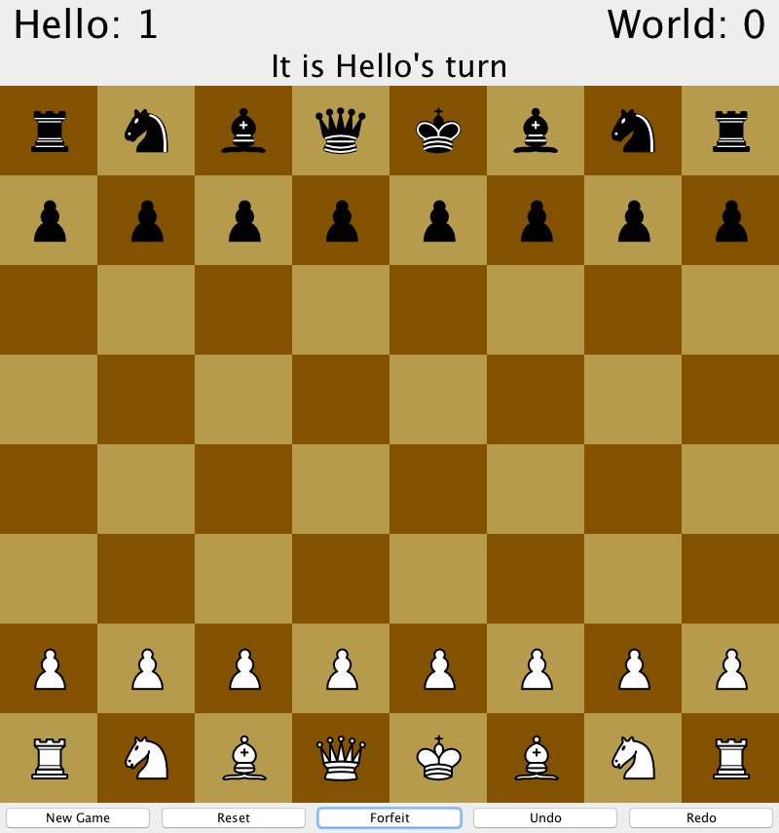

**Test 16: New Game from Play Again**

Steps:

1. Repeat steps from Test 15
2. Press “New Game” [Fig 1]
3. Press “OK” [Fig 2]

Observe:

* Fig 1
  + Dialog prompts the user to enter their names
* Fig 2
  + The black pieces are laid out on the top and white pieces are laid on on the bottom
  + The pieces are all laid out following the rules of a traditional chess game
  + Player names are changed to input values
  + Scores are reset to 0
  + Turn is changed to CS

Screenshot:

1: 2:

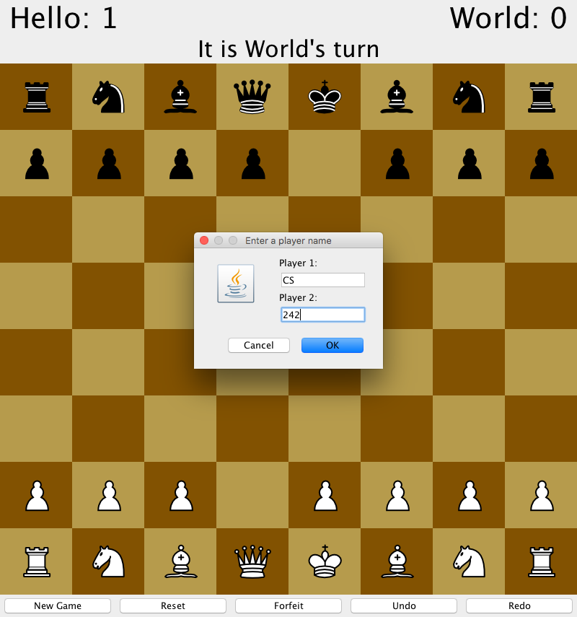 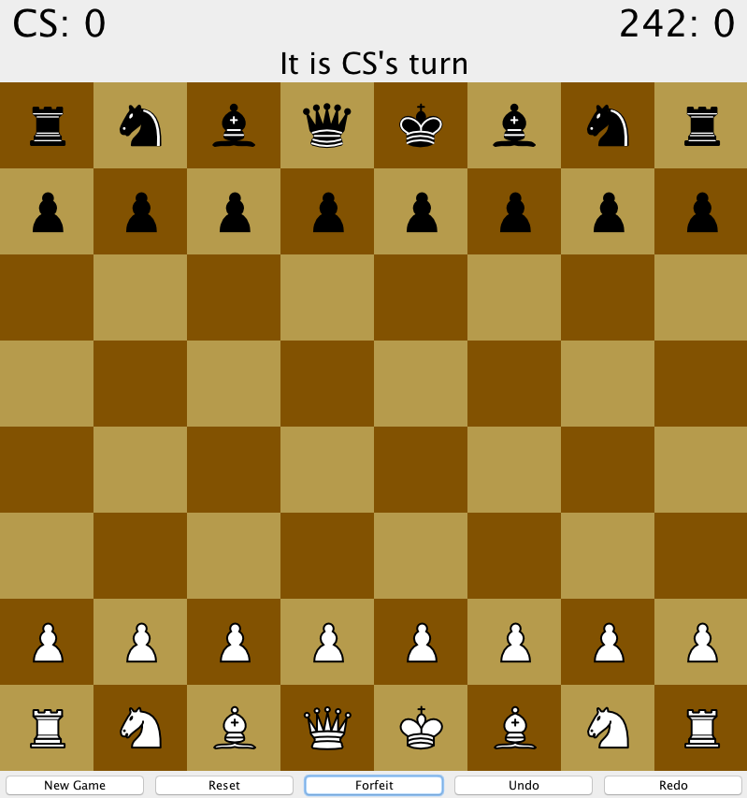

**Test 17: Reset Game from Button**

Steps:

1. Repeat steps from Test 15
2. Press “Reset” [Fig 1]
3. Press “OK” [Fig 2]

Observe:

* Fig 1
  + There is a pop-up dialog that confirms if the users want to reset the game
* Fig 2
  + The black pieces are laid out on the top and white pieces are laid on on the bottom
  + The pieces are all laid out following the rules of a traditional chess game
  + Player names are kept the same as before
  + Hello’s score is kept the same as before
  + Turn is kept as Hello

Screenshot:

1: 2:

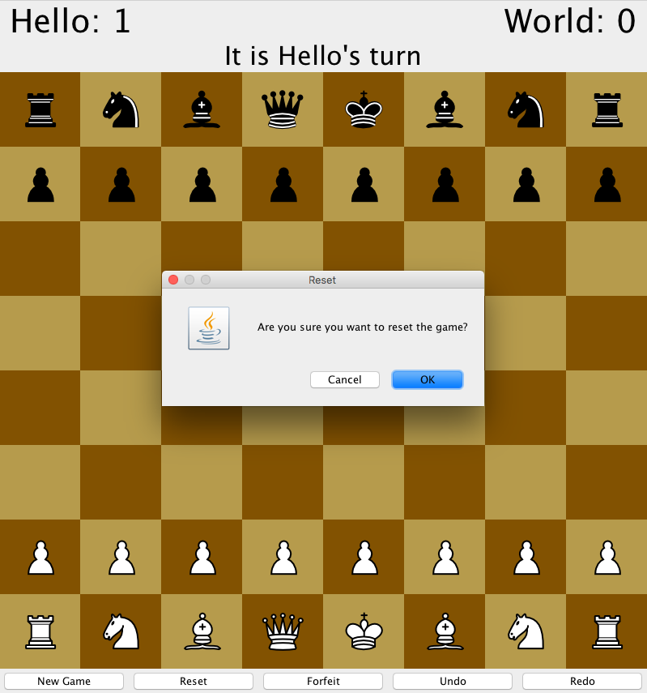 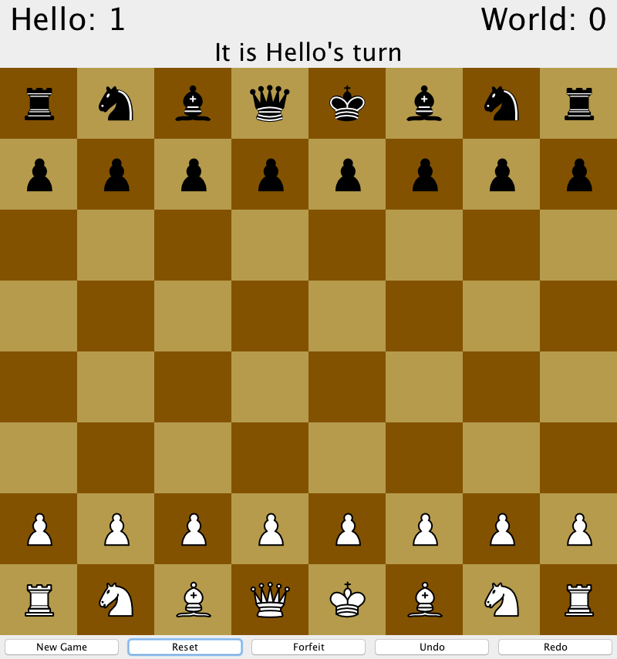

**Test 18: New Game from Button**

Steps:

1. Repeat steps from Test 16
2. Press “New Game” [Fig 1]
3. Press “OK” [Fig 2]
4. Enter “CS” and “242” [Fig 3]
5. Press “OK” [Fig 4]

Observe:

* Fig 1
  + There is a pop-up dialog that confirms if the users want to start a new game
* Fig 2
  + There is a pop-up dialog that allows user to enter new player names
* Fig 3
  + Users can type the new names into the text fields
* Fig 4
  + The pieces are all laid out following the rules of a traditional chess game
  + Player names changed to the new names and scores are reset
  + Turn is changed to CS

Screenshot:

1: 2:

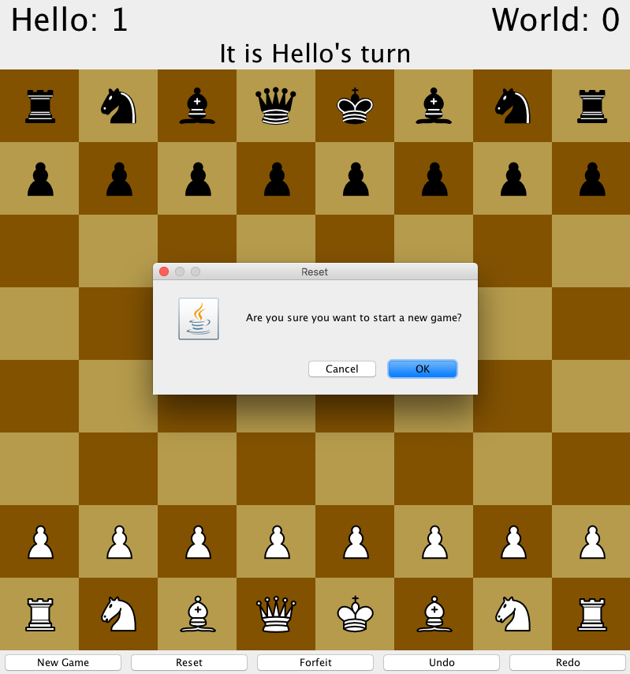 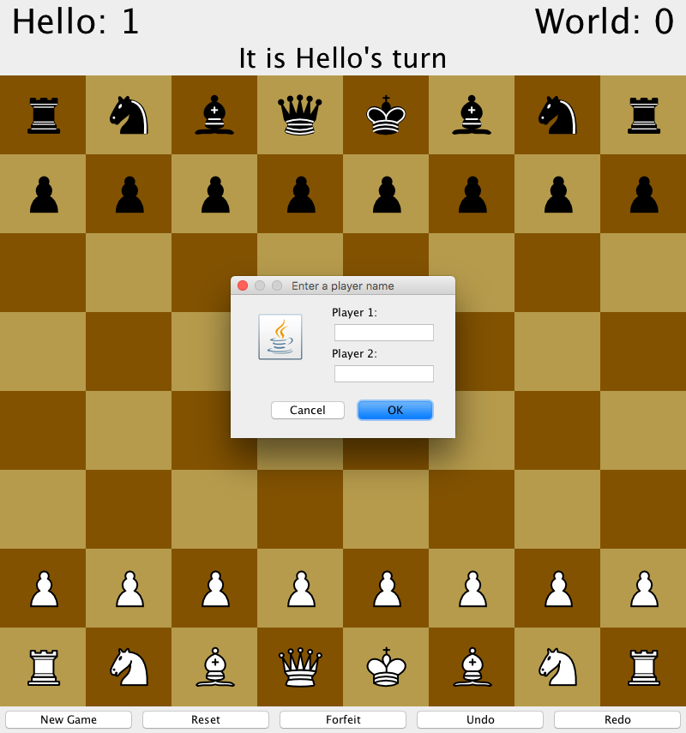

3: 4:

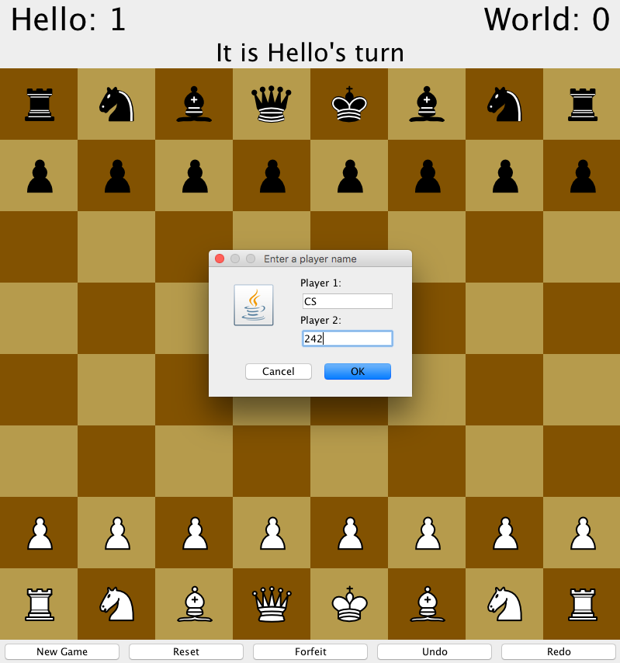 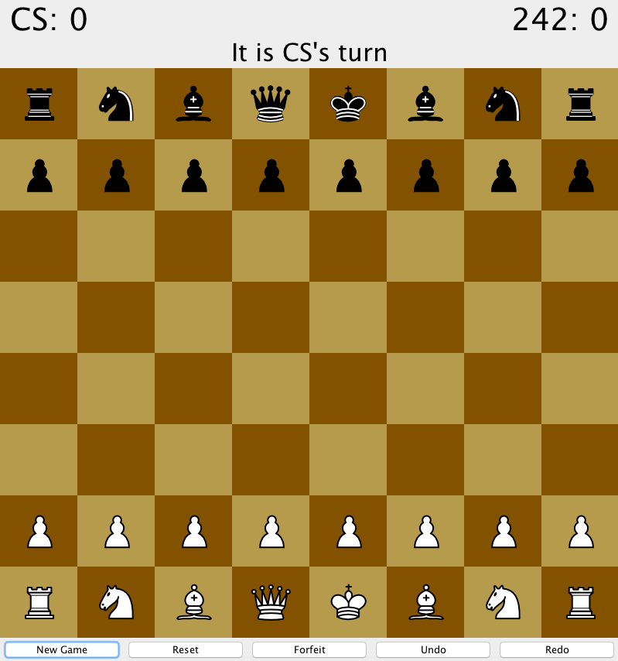

**Test 19: Check Situation**

Steps:

1. Move White Pawn from (3,6) to (3,5)
2. Move Black Pawn from (2,1) to (2,2)
3. Move White Bishop from (2,7) to (4, 5)
4. Move Black Pawn from (3,1) to (3,2)
5. Move White Bishop from (4,5) to (1,2)

Observe:

* There is a pop-up dialog that warns the opponent that they are in check

Screenshot:

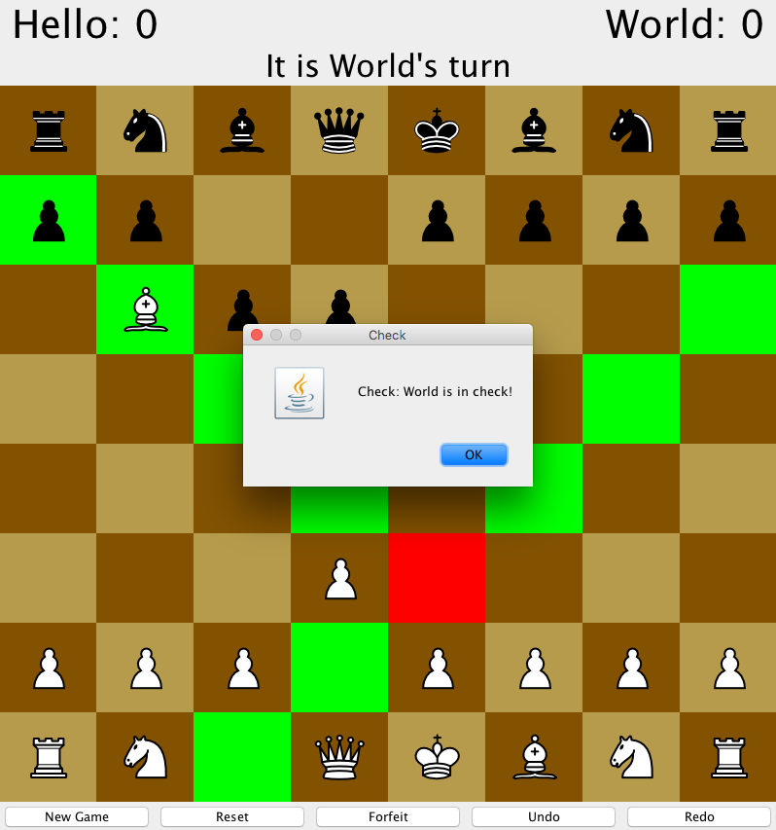

**Test 20: Checkmate Situation**

Steps:

1. Move White Pawn from (3,6) to (3,5)
2. Move Black Pawn from (2,1) to (2,2)
3. Move White Bishop from (2,7) to (4, 5)
4. Move Black Pawn from (0,1) to (0,2)
5. Move White Bishop from (4,5) to (1,2) [Fig 1]
6. Press “OK” [Fig 2]

Observe:

* Fig 1
  + There is a pop-up dialog that shows the game is in checkmate and which player won
* Fig 2
  + The play again dialog is displayed
  + Hello’s score is increased to 1

Screenshot:

1: 2:

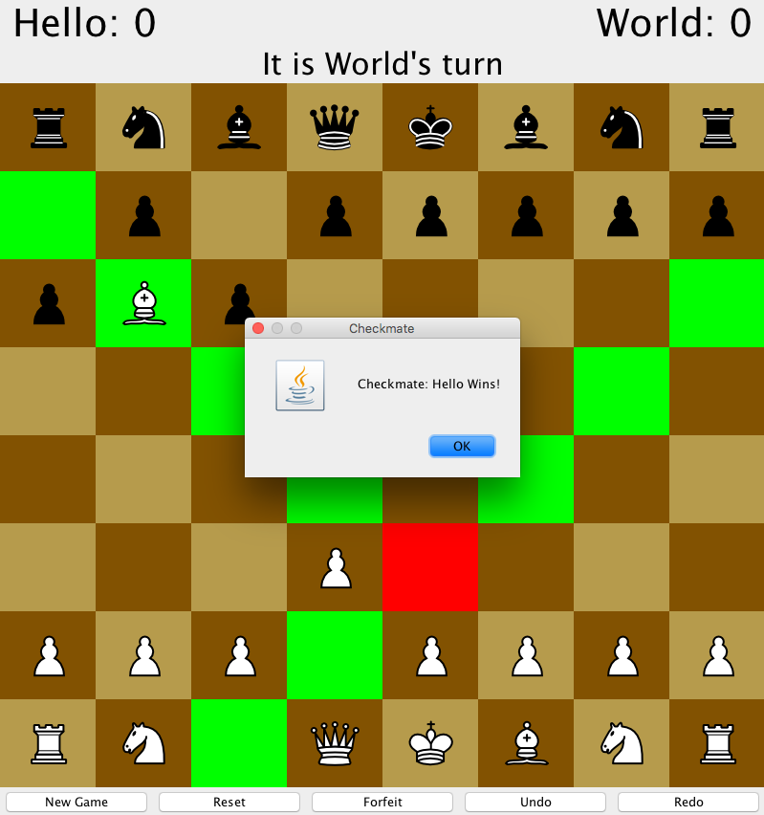 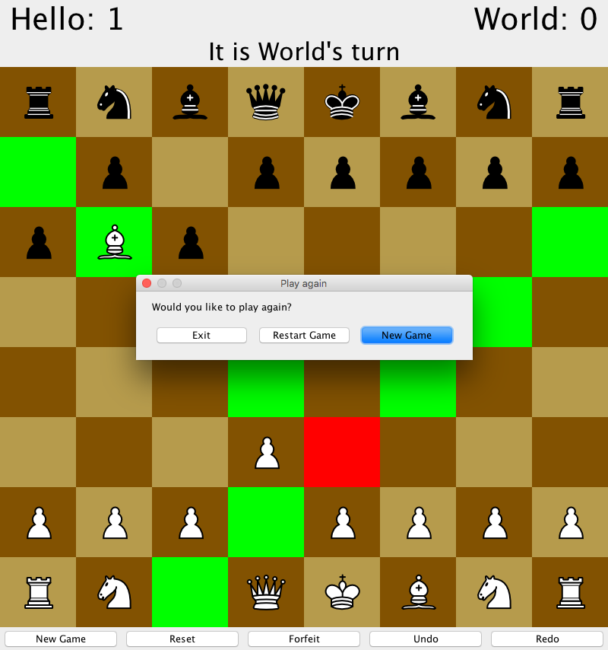

**Test 21: Stalemate Situation**

Steps:

1. Move White Pawn from (4,1) to (4,2)
2. Move Black Pawn from (0,1) to (0,3)
3. Move White Queen from (3,7) to (7, 3)
4. Move Black Rook from (0,0) to (0,2)
5. Move White Queen from (7,3) to (0,3)
6. Move Black Pawn from (7,1) to (7,3)
7. Move White from (0,3) to (2,1)
8. Move Black Rook from (0,2) to (7,2)
9. Move White Pawn from (7,6) to (7,4)
10. Move Black Pawn from (5,1) to (5,2)
11. Move White Queen from (2,1) to (3,1)
12. Move Black King from (4,0) to (5,1)
13. Move White Queen from (3,1) to (1,1)
14. Move Black Queen from (3,0) to (3,5)
15. Move White Queen from (1,1) to (1,0)
16. Move Black Queen from (3,5) to (7,1)
17. Move White Queen from (1,0) to (2,0)
18. Move Black King from (5,1) to (6,2)
19. Move White Queen from (2,0) to (4,2) [Fig 1]
20. Press “OK” [Fig 2]

Observe:

* Fig 1
  + There is a pop-up dialog that shows the game is in stalemate
* Fig 2
  + The play again dialog is displayed
  + Neither’s players scores are changed because it is a tie

Screenshot:

1: 2:

